Write a Prolog Program for STUDENT-TEACHER-SUB-CODE.

AIM
To implement a Prolog program to represent the relationship between students, teachers, and subject codes using facts and rules, and to retrieve the required information using Prolog queries.
OBJECTIVE
- To understand the use of facts and rules in Prolog.
- To represent student, teacher, and subject information.
- To establish relationships between students, teachers, and subjects.
- To retrieve information using logical queries.

ALGORITHM
Step 1: Start.
Step 2: Define the students using Prolog facts.
Step 3: Define the teachers using Prolog facts.
Step 4: Define the subjects and their subject codes.
Step 5: Define which teacher handles each subject.
Step 6: Define which student studies each subject.
Step 7: Create rules to find:
- Subjects studied by a student.
- Teacher handling a subject.
- Subjects handled by a teacher.
- Subject code for a particular subject.
Step 8: Execute queries to retrieve the required information.
Step 9: Display the results.
Step 10: Stop.

SOURCE CODE
Program:
% define some facts about teachers and their subject codes
teaches(john, math).
teaches(jane, english).
teaches(bob, science).
teaches(sue, history).
teaches(tom, art).
% define some facts about students and the subjects they are taking
takes(alice, math).
takes(alice, science).
takes(bob, english).
takes(bob, science).
takes(carol, history).
takes(carol, art).
takes(dave, math).
takes(dave, english).
takes(dave, art).
% define a predicate to look up the subject codes taught by a teacher
teaching_subjects(Teacher, Subject) :-
teaches(Teacher, Subject).
SAVEETHA SCHOOL OF ENGINEERING
SAVEETHA INSTITUTE OF MEDICAL AND TECHNICAL SCIENCES
64
% define a predicate to look up the students taking a given subject
taking_students(Subject, Student) :-
takes(Student, Subject).

% example query: find the subjects taught by john
?- teaching_subjects(john, Subject).
Subject = math.
% example query: find the students taking science
?- taking_students(science, Student).
Student = alice ;
Student = bob.
% example query: find the students taking math and art
?- taking_students(math, Student), taking_students(art, Student).

OUTPUT
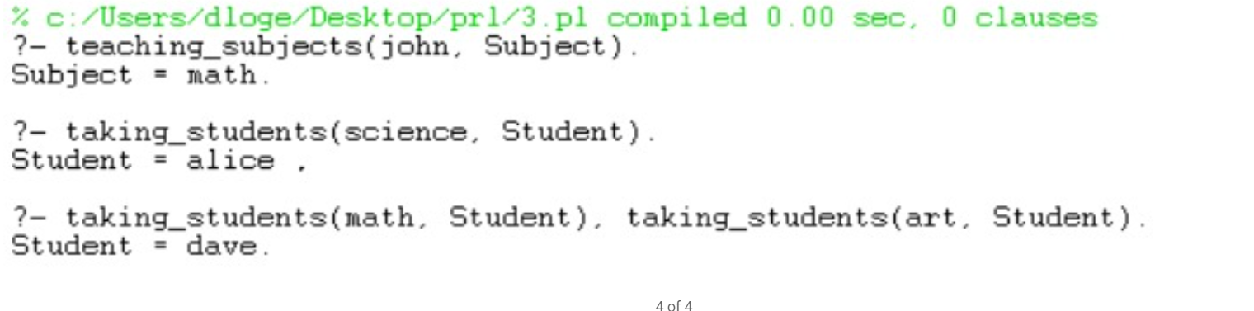
FLOWCHART
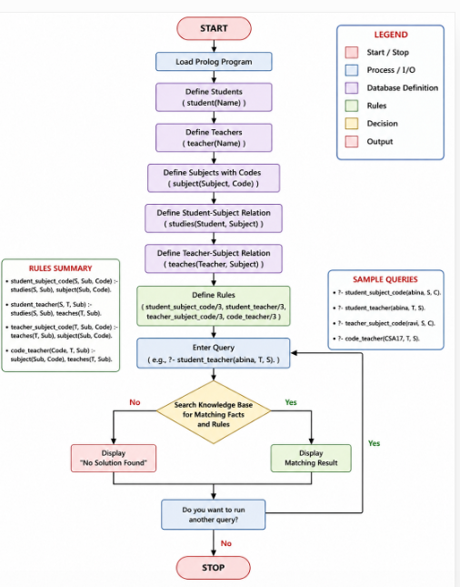

RESULT
The Prolog program was successfully implemented to represent the relationships between students, teachers, subjects, and subject codes. The required information was retrieved successfully using Prolog facts, rules, and queries.
CONCLUSION
Thus, the Student–Teacher–Subject Code database was successfully implemented using Prolog. The program demonstrates how Prolog uses facts, rules, variables, and logical queries to represent relationships and derive required information from a knowledge base.

